WDA/EAZWV/EAAV Mentoring Programme 2022/2023
Guidelines for Participants

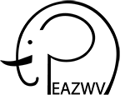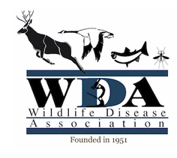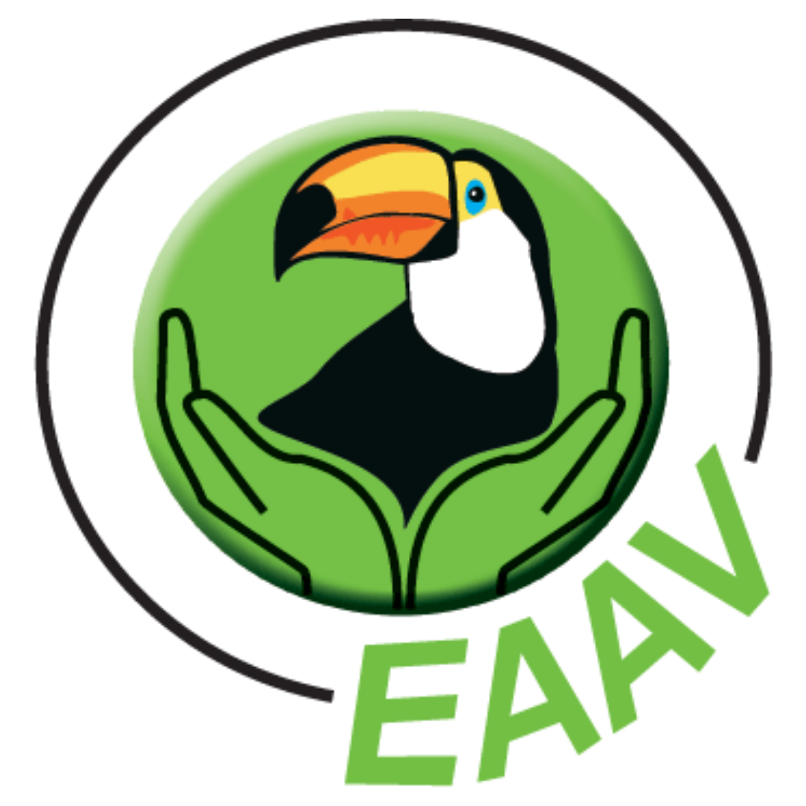

Introduction

Welcome to the WDA/EAZWV/EAAV mentoring programme. This is a joint initiative between the Wildlife Disease Association (WDA), the European Association of Zoo and Wildlife Veterinarians (EAZWV) and the European Association of Avian Veterinarians (EAAV) to promote the sharing of knowledge and skills and to help maintain a strong connection between the professionals of our organisations.

This is a competitive program in which, in order to be accepted, mentees will have to show their motivation to become professionals in the field of zoo and wildlife health. Likewise, mentors will be expected to show a high level of commitment as well, and to help the mentees to get the most out of this programme.

The pairing between mentors and mentees will be performed manually, and the best effort will be made to satisfy everyone’s preferences. However, please, be aware they may not all be met due to the number and characteristics of the participants.

Priority during selection will be given to recent graduates or final year vet students.

What is mentorship?

“Mentoring is a system of semi-structured guidance whereby one person shares their knowledge, skills and experience to assist others to progress in their own lives and careers.“
-University of Cambridge

A mentor is a coach, networker and advisor
A mentor:
● Is a source of information.
● Gives suggestions on how to achieve professional goals.
● May recommend possible resources to improve certain skills.
● Helps to solve professional challenges.
● Listens and gives information and advice when requested to.

A mentor is NOT:

● A wizard: they are not here to fix all the mentee’s problems.
● A parent: the mentee should not become dependent on them to make decisions.
● A sergeant: the mentor should not control all the mentee’s decisions.
● Here to do the mentee’s applications, but only to give advice on them if asked.
This is NOT a recruitment program.

What are the benefits?

For Mentees:

● Exposure to new ideas and ways of thinking.
● Guidance through a professional decision or choice.
● Assistance in developing strengths and/or overcoming weaknesses.
● Improves self-confidence.

⇨ Please keep these in mind and build from them when completing your application form. Tell us how you personally would most benefit from this mentoring programme.

For Mentors:

● Satisfaction.
● Opportunity to reflect on one’s own practice.
● Opportunity to use and widen one’s own experience.
● Developing a network of relationships.
● Exposure to new ideas.
● Further developing leadership and communication skills.

Meetings & Communication

The mentees have the responsibility of establishing first contact. They will be given the mentor’s contact details and communication preference as per their application.

Participants are encouraged to decide between themselves how often they would like to communicate and through which means. Prior to having a meeting it is a good idea for mentees to make a list of the questions they want to ask, and note what tasks should be done before the next one.

Meetings should be set up in a way in which both parties are comfortable, they do not have to be face to face. Due to the variety of participants, mentors and mentees may not be geographically close to each other. However, it is encouraged to set up a meeting at a future conference or other scientific event. Communication online can be done through many platforms, from email to apps such as WhatsApp/Telegram or Skype/Zoom/Teams.

Professionalism & Confidentiality

Both mentors and mentees are requested to treat each other in a sensible and considerate manner, respecting everybody’s feelings and culture. Likewise, they are expected to show ethical behaviour and promote professionalism in their field.

Confidentiality is important in keeping an efficient mentoring relationship. Spread rumours or privately-shared information that may be of a sensitive nature is strictly forbidden. Information can only be disclosed with the explicit agreement of the other person. If such a rule is broken, necessary punitive action will be taken, including but not limited to expulsion from the programme.

Please, report any breach of these guidelines to the organisers of the mentoring program

Mental Health Issues

The mentoring programme is an exclusively professional programme. Mentors are not equipped to directly deal with possible mental health issues that mentees may face and share with them. Mentors should not try to deal with these issues themselves, but direct their mentees to the proper resources.
The mentoring programme provides a list of helplines and resources for the participants if the issue does arise.
Mentors will also be able to contact the programme coordinators for more advice on how to proceed.

Mentor Training and Support

Mentors will receive webinar training by a professional coaching and mentorship company. In addition, for the duration of the programme, mentors will receive support from the organisers and will be able to communicate with each other and with support staff should any questions or issues arise.

Feedback

Both mentors and mentees will receive an official feedback form twice: one halfway the programme and one at the end. Likewise, participants will be able to send feedback or questions at any time throughout the year at wildlifementoringprogram@gmail.com

When writing feedback, the participants are invited to reflect on their experience and note which areas they feel are particularly well organised and what could be improved next time (whether it be a personal thing the participant may do differently or a way the program could improve). Participants are encouraged to give constructive criticism about their paired mentor/mentee, as well as to offer tips for future participants.

