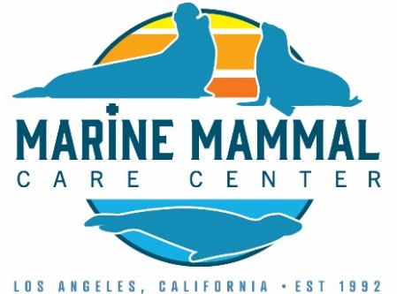
Job Description : Associate Veterinarian Marine Mammal Care Center Los Angeles
The Marine Mammal Care Center Los Angeles (“MMCC”), is accepting applications for a full-time seasonal, Associate Veterinarian to work during the busy marine mammal stranding season from February through July 2023. The location of this position is onsite in San Pedro, CA
Primary responsibilities
- Assist the staff veterinarian with medical diagnosis and treatment of rehabilitating patients, primarily California sea lions, northern elephant seals, harbor seals and fur seals
- Complete admission and pre-release examinations
- Write SOAPS, daily treatment plans, and assist with maintenance of medical records and stranding data for NMFS national database including Level A, Human Interaction and Final Disposition forms
- Be familiar with sedation and anesthesia protocols for pinnipeds
- Work up diagnostic cases to the extent financially and technically possible
- Complete necropsies and necropsy reports, collect samples, for research and histopathology and send samples out to various labs as indicated for selected cases
- Implement NMFS Policies and Best Practices, Marine Mammal Stranding Response, Rehabilitation and Release Standards to the fullest extent achievable
- Be willing to assist in other animal care related tasks as might be necessary
Education and Outreach
- Assist with training of third and fourth-year veterinary student externs
- Communicate with volunteers and the public on marine mammal cases of interest
- Presentation of public outreach and scientific lectures as needed

Culture of Philanthropy
- Supports MMCC development team and enhances donor relationships by sharing their passion for service to our animals and ocean conservation
- Being knowledgeable and supportive of development programs
- Assist with grant tracking/applications as needed
- Serving as an inspiration to all guests by providing an exemplary level of animal care and visitor stewardship

Essential Qualifications and Skills
- DVM/VMD degree from accredited university
- Hold a current DVM license in a US state
- Required licenses, certifications and registrations must be maintained throughout employment
- Have completed a small, large, or aquatic animal post graduate internship
- Have knowledge of principles and practice of current veterinary medicine, animal diseases, their prevention, control, and eradication
- Have knowledge of current veterinary practices and techniques relating to treatment of injured animals
- Be cooperative and collaborative with team members, volunteers, partner researchers, and stranding network partners
- Be fluent in English
Physical Demands
- Job requires periods of 4 to 6 hours of standing, stretching and bending
- Must be able to stand, walk, sit, talk and hear, stoop, bend, squat, kneel, grasp and grip, put fingers together firmly and reach above and below shoulder level and lift, push or pull 50 pounds for situations of restraining or moving animals and lifting supplies, materials, and equipment
- Repetitively use hands to operate computers and medical equipment
- Be able to work outdoors in inclement weather
- Reasonable accommodations may be made to enable individuals with disabilities to perform the essential functions.
Compensation
- Compensation is based on a $75,000 annual salary, prorated monthly
- The position is based on a full-time work week of at least 40hrs per week. Schedule to be determined by supervisor and is subject to change and weekend and holiday work may be required
- Other benefits include:
  - Paid vacation benefits of 7 days per 6-month period
  - Unpaid time off to be arranged with supervisor if needed
How to Apply
Applications will be reviewed as received until an appropriate candidate is selected.
MMCC is an equal opportunity employer. We celebrate diversity and are committed to creating an inclusive environment in the workplace.
If interested in applying for this position please send your CV, list of references, and a cover letter to lpalmer@marinemammalcare.org.
In the subject line please write your last name and Seasonal Vet Position 2023.

