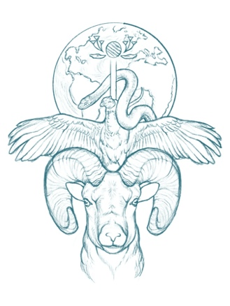

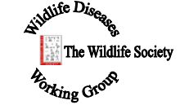
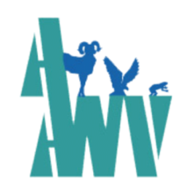
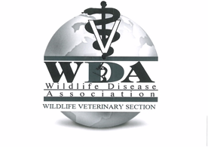

Trilateral Wildlife Health Webinar Series
Date: Thursday, April 28th, 12 PM USA EDT.
Title: “Disease in a Hard Shell: A Tough Case to Crack - Challenges to Investigating Mussel Mortality and Declines”
Synopsis: Freshwater mussels are keystone species for river basin ecosystems because they provide crucial services including biofiltration and nutrient cycling. However, their numbers have dramatically declined in North America, and mortality outbreaks of unknown cause have been increasingly problematic in recent decades. Researchers engaged with studying these mortality outbreaks face many challenges, necessitating a One Health approach to disease investigation.
Presenter: Michelle Dennis, DVM, PhD, DACVP
Dr. Michelle Dennis is a board certified veterinary anatomic pathologist and Associate Professor in the Department of Biomedical and Diagnostic Sciences at the University of Tennessee College of Veterinary Medicine. She graduated from Purdue University School of Veterinary Medicine in 2002 and completed a combined pathology residency and PhD program at Colorado State University in 2007. Her research has focused on comparative pathology and investigation of natural disease with a special interest in aquatic animals. Her research has primarily addressed disease in wildlife species of ecological and economic importance, including corals, spiny lobster, sea urchins, freshwater mussels, perinatal hawksbill and leatherback sea turtles, and Antillean manatees.

Join Zoom Meeting
https://zoom.us/j/95992218723

Meeting ID: 959 9221 8723
One tap mobile
+13017158592,,95992218723# US (Washington DC)
+13126266799,,95992218723# US (Chicago)

Dial by your location
+1 301 715 8592 US (Washington DC)
+1 312 626 6799 US (Chicago)
+1 929 205 6099 US (New York)
+1 253 215 8782 US (Tacoma)
+1 346 248 7799 US (Houston)
+1 669 900 6833 US (San Jose)
Meeting ID: 959 9221 8723
Find your local number: https://zoom.us/u/awigWyr8G

